**23.AUTOMATION TESTING USING SELENIUM TOOL FOR SHOPPING DOMAIN**

**AIM :**

To execute Automation testing using Selenium tool for shopping Domain.

**PROGRAM** :

package chennai;

import org.openqa.selenium.By;

import org.openqa.selenium.WebDriver;

import org.openqa.selenium.WebElement;

import org.openqa.selenium.chrome.ChromeDriver;

//import org.testng.Assert;

//import org.testng.annotations.Test;

public class sellinium1 {

public static void main(String[] args) {

System.out.println("hai");

System.setProperty("webdriver.chrome.driver","C:\\manik\\CSA37 Lab

details\\Sellinium and junit\\selenium

jar\\chromedriver_win32\\chromedriver.exe");

WebDriver driver = new ChromeDriver();

//driver.get("https://www.google.com/");

driver.manage().window().maximize();

driver.get("https://amazon.com");

WebElement

username=driver.findElement(By.id("txtusername"));

System.out.println(username);

WebElement password=driver.findElement(By.id("txtpassword"));

System.out.println(password);

WebElement login=driver.findElement(By.name("btnlogin"));

System.out.println(login);

username.sendKeys("indupriya");

password.sendKeys("INDU@123");

login.click(); }

}

**OUTPUT:**

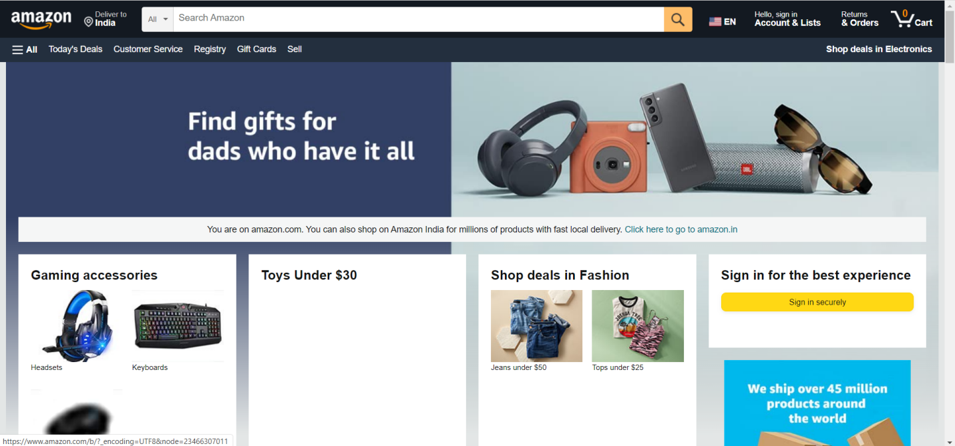

**RESULT:**

Hence Automation testing for shopping Domain is Executed successfully.